
IP Communications Applications for Business Advantage

Metreos Record Agent®

User Guide
Metreos Communications Environment 2.1

Proprietary and confidential
For release under NDA only

www.metreos.com | Part Number M-2400-ASUG-15
 | 9/2005

Information in this document is subject to change without notice.

Copyright © 2005 Metreos Corporation. All rights reserved. Metreos trademarks marked with ® or © herein are registered or protected trademarks of Metreos in the U.S. and foreign countries. All other trademarks in the document are the property of their respective owners.

Preface
This manual describes the installation and usage of the Beta 1 release of the Metreos Record Agent® application for Cisco IP telephones and the Metreos Communication Environment.

Intended Audience
This manual is intended for use by anyone wishing to install and/or use the Metreos Record Agent application to record telephone conversations occurring on their Cisco 7940, 7960, or 7970 IP telephone.

Content of This Document
This manual describes:
- Installation and setup procedures for the Record Agent application.
- Operation of the Record Agent application.

Style and Formatting Conventions
The following typographical components are used for defining special terms and command syntax:

Convention | Description
Bold typeface | Represents literal information such as  - Information and controls displayed on screen, including menu options, windows dialogs and field names  - Commands, file names, and directories  - In-line programming elements, such as class names and XML elements when referenced in the main text
Italic typeface | Italics typeface is used to denote  - A new concept  - A variable element such as filename.mca. In this example, filename represents the filename and .mca is the extension.  - A reference to a chapter or section heading
Sans serif typeface | Denotes code or code fragments
… (ellipsis) | Denotes omitted material
UPPERCASE | Denotes keys and keystroke combinations such as CTRL+ALT+DEL.

Licensing Terms

Use of this Software is subject to license restrictions. Carefully read this license agreement before using the software.

This End User License Agreement (the “Agreement”) is a legal agreement between you, either individually or as an authorized representative of the company or organization acquiring the license, and Metreos Corporation (“Metreos”). USE OF SOFTWARE INDICATES YOUR COMPLETE AND UNCONDITIONAL ACCEPTANCE OF THE TERMS AND CONDITIONS SET FORTH IN THIS AGREEMENT. If you do not agree to these terms and conditions, promptly return or, if electronically received, certify destruction of the Software and all accompanying items within five days after receipt of Software and you will receive a full refund of the applicable license fees paid.

1. License Grant

a. The software programs you are installing, downloading, or have acquired with this Agreement, including any related equipment or hardware, documentation, updates, upgrades, modifications, revisions, copies and design data (“Software”) are copyrighted, trade secret and confidential information of Metreos and its licensors who maintain exclusive title to all Software and retain all rights not expressly granted by this Agreement. Metreos grants to you, subject to payment of appropriate license fees, a non-exclusive, non-transferable, internal-use only, term license to use the Software owned or distributed by Metreos in machine readable, object-code form on the computer hardware or at the site(s) for which an applicable license fee has been paid, as authorized by Metreos.

b. To the extent that you design applications that operate on the Metreos Communications Environment (the “MCE”), Metreos grants you a non-exclusive, non-transferable, internal-use only, term license to use the Software, including the MCE, for the purposes of operating such programs, subject to payment of appropriate license fees.

c. The license granted herein is contingent on your (or your organization’s) continued acceptance and subscription to the maintenance and support terms provided by Metreos. Termination by you or your organization of ongoing maintenance and support requirements terminates the license granted herein.

2. Restrictions and Intellectual Property Ownership

a. You may not (i) remove or modify any notice of Metreos’ proprietary rights, (ii) re-license, rent, lease, timeshare, or act as a service bureau or provide subscription services for the Software, (iii) use the Software to provide third-party training, except for training agents and contractors authorized under this Agreement; (iv) assign this Agreement or give the Software or an interest in the Software to another individual or entity; (v) cause or permit reverse engineering or decompilation of the Software; (vi) disclose results of any Software benchwork tests without Metreos’ prior written consent; or (vii) modify the Software or any portions thereof without Metreos’ prior written consent.

b. The Software, which is copyrighted, and any modifications, upgrades, or updates thereto, is the sole and exclusive property of Metreos and is a valuable asset and trade secret of Metreos. Metreos retains all ownership and intellectual property rights to the Software and to any modifications, upgrades, or updates thereto. Except for the rights granted in herein above, you shall have no right, title, or interest of any kind in or to the Software.

c. Metreos may audit your use of the Software. If Metreos gives you or your organization reasonable advance written notice, you agree to cooperate with the audit, and to provide reasonable assistance and access to information. You agree to immediately remit any underpaid license and technical support fees determined as the result of such audit.

3. Term and Termination.

a. This Agreement remains effective until expiration or termination. This Agreement will immediately terminate upon notice if you exceed the scope of the license granted or otherwise fail to comply with the provisions in sections 1 and 2 above. For any other material breach of the Agreement, Metreos may terminate this Agreement if you are in breach and fail to cure the breach within thirty (30) days of written notification. If Software is provided for a limited term use, this Agreement will automatically expire at the end of the authorized term.

b. Upon termination of this Agreement for any reason, you shall within ten (10) business days return to Metreos all Software. Additionally, you agree to delete from any permanent machine storage (i.e., hard disk) previously loaded copies of the Software in all forms. Upon request of Metreos, you shall certify in writing that all copies of the Software and associated documentation have been destroyed or returned to Metreos. The indemnity and limitation of liability obligations hereunder, as well as your obligations with respect to confidential treatment of the Software and Metreos’ trade secrets, other intellectual property, and proprietary information, shall survive the termination of this Agreement.

4. Limited Warranty.

a. Metreos warrants that the Software will substantially operate as described in the applicable Software documentation for ninety (90) days after Metreos delivers it to you. THE WARRANTY HEREIN IS EXCLUSIVE AND IN LIEU OF ALL OTHER WARRANTIES, WHETHER EXPRESS OR IMPLIED, INCLUDING THE IMPLIED WARRANTIES OF MERCHANTABILITY AND FITNESS FOR A PARTICULAR PURPOSE. METREOS MAKES NO WARRANTY THAT ANY SOFTWARE WILL PERFORM ERROR-FREE OR UNINTERRUPTED, OR THAT ALL ERRORS THEREIN CAN OR WILL BE CORRECTED. METREOS FURTHER DISCLAIMS ANY IMPLIED WARRANTIES ARISING FROM COURSE OF PERFORMANCE, COURSE OF DEALING OR USAGE OF TRADE.

b. For any breach of the above warranty, Metreos’ entire liability and your exclusive remedy shall be, at Metreos’ option, either (1) refund of the fees paid upon return of the Software to Metreos, or (2) correction or replacement of the Software that does not meet this limited warranty, provided you have complied with the terms of this Agreement.

5. Indemnity

a. Metreos will defend and indemnify you against a claim that any Software, infringes a patent or copyright, provided that: (i) you notify Metreos in writing within thirty (30) days of the claim; (ii) Metreos has sole control of the defense and all related settlement negotiations; and (iii) you provide Metreos with the assistance, information, and authority reasonably necessary to perform the above; reasonable out-of-pocket expenses incurred by you in providing such assistance will be reimbursed by Metreos.
b. Metreos shall have no liability for any claim of infringement resulting from: (i) your use of a superseded or altered release of the Software if infringement would have been avoided by the use of a subsequent unaltered release of the Software which Metreos provides to you; or (ii) any information, design, specification, instruction, software, data, or material not furnished by Metreos or (iii) any combination of the Software with other hardware, software or processes that, but for the combination, the Software would not be infringing.
c. In the event that some or all of the Software is held or is believed by Metreos to infringe, Metreos shall have the option, at its expense: (i) to modify the Software to be non-infringing; or (ii) to obtain for you a license to continue using the Software. If it is not commercially feasible to perform either of the above options, then Metreos may require from you return of the infringing Software and all rights thereto. Upon return of the infringing Software to Metreos, you may terminate the Agreement with ten (10) days’ written notice and you shall be entitled to a pro-rata refund of the fees paid for the infringing Software. This subsection sets forth Metreos’ entire liability and exclusive remedy for infringement.
d. You will defend and indemnify Metreos and its licensors against any claim incurred by, borne by or asserted against Metreos or its licensors that relates to or results from (i) your use of the Software, (ii) any intentional or willful conduct or negligence by you or (iii) any breach of an applicable representation, covenant or warranty contained herein.
e. Should the party seeking indemnification (“Indemnitee”) reasonably determine that the party from whom indemnity is sought (“Indemnitor”) has failed to assume the defense of any claim referenced herein, Indemnitee shall have the right to assume such defense and have all expense and cost of the defense reimbursed by Indemnitor, including reasonable attorneys fees.

6. Confidentiality

The Software contains proprietary and confidential information of Metreos as well as trade secrets owned by Metreos. You agree to hold the Software in strict confidence and not to disclose the Software in any way except as expressly permitted hereunder. You agree to protect the Software at least to the same extent that you protect your similar confidential information, but in no event less than reasonable care. You further agree that you will not, directly or indirectly, copy the structure, sequence, or organization of the Software, nor will you copy any portion of the Software or related documentation to produce software programs that are substantially similar to the Software.

7. LIMITATION OF LIABILITY

EXCEPT WHERE THIS EXCLUSION OR RESTRICTION OF LIABILITY WOULD BE VOID OR INEFFECTIVE UNDER APPLICABLE LAW, IN NO EVENT WILL METREOS BE LIABLE FOR ANY INDIRECT, INCIDENTAL, SPECIAL, OR CONSEQUENTIAL DAMAGES, OR DAMAGES FOR LOSS OF PROFITS, REVENUE, DATA, OR USE, INCURRED BY YOU OR ANY THIRD PARTY, WHETHER IN AN ACTION IN CONTRACT OR TORT, EVEN IF METREOS OR ANY OTHER PERSON HAS BEEN ADVISED OF THE POSSIBILITY OF SUCH DAMAGES. METREOS’ LIABILITY FOR DAMAGES HEREUNDER SHALL IN NO EVENT EXCEED THE AMOUNT OF FEES PAID BY YOU FOR THE SOFTWARE OR SERVICE GIVING RISE TO THE CLAIM. IN THE CASE WHERE NO AMOUNT WAS PAID, METREOS SHALL HAVE NO LIABILITY FOR ANY DAMAGES WHATSOEVER.

8. Assignment; Jurisdiction.

This Agreement will be binding upon, and will inure to the benefit of, the permitted successors and assigns of each party hereto. You may not assign, delegate, transfer, or otherwise convey this Agreement, or any of its rights hereunder, to any entity without the prior written consent of Metreos, and any attempted assignment or delegation without such consent shall be void. This Agreement, and all matters arising out of or relating to this Agreement, shall be governed by the laws of the State of Texas, United States of America. Any legal action or proceeding relating to this Agreement shall be instituted in any state or federal court in Travis or Dallas County, Texas, United States of America. Metreos and you agree to submit to the jurisdiction of, and agree that venue is proper in, the aforesaid courts in any such legal action or proceeding.

9. Severability; Waiver

In the event any provision of this Agreement is held to be invalid or unenforceable, the remaining provisions of this Agreement will remain in full force. The waiver by either party of any default or breach of this Agreement shall not constitute a waiver of any other or subsequent default or breach. Except for actions for nonpayment or breach of either party’s intellectual property rights, no action, regardless of form, arising out of this Agreement may be brought by either party more than two years after the cause of action has accrued. The headings appearing in this Agreement are inserted for convenience only, and will not be used to define, limit or enlarge the scope of this Agreement or any of the obligations herein.

10. Restricted Rights Notice.

The Software is commercial in nature and developed solely at private expense. The Software is delivered as "Commercial Computer Software" as defined in DFARS 252.227-7014 (June 1995) or as a commercial item as defined in FAR 2.101(a) and as provided with only such rights as are provided in this Agreement, which is Metreos’ standard commercial license for the Software. Technical data is provided with limited rights only as provided in DFAR 252.227-7015 (Nov. 1995) or FAR 52.227-14 (June 1987), whichever is applicable.

Table of Contents

Preface iii
Intended Audience iii
Content of This Document iii
Style and Formatting Conventions iii
Licensing Terms iv
Table of Contents vii
Metreos Record Agent 8
Background 8
Telephony Requirements 8
Computer System Requirements 8
Installation and Configuration 10
Configuring Metreos Record Agent 10
Configuring the Phone with Cisco CallManager 10
Connecting the Agent Phone to the Agent PC 10
Configuring the Record Agent Software 10
Installing Metreos Record Agent 11
Using Metreos Record Agent 12
The System Tray 12
Call Notifications 12
Recording a Call 13
Recording from the Call Notification Popup 13
Recording from the System Tray Menu 13
Recording from the Main Application Screen 14
Annotating a Call 14
Managing and Playing Call Recordings 15
Reviewing and Playing Back a Call 15
Locating Conversations by Annotation Content 15
Bookmarking a Call 16
Saving a Call 16

Metreos Record Agent
The Metreos Record Agent® solution for agent call recording permits secure network-independent recording, annotation, and playback of calls to and from your Cisco IP telephone.

Background
Until now, most recording solutions for Cisco CallManager have been based on capturing network traffic within the network core. Such solutions require SPAN ports to be created on core network switches, a less than ideal deployment model, particularly within networks where SPAN port availability is limited. Even those solutions which may not require the use of SPAN ports will typically require significant and complex call routing configuration.

A less intrusive solution is needed, for those environments that
- Require user- controlled and maintained call recordings.
- Do not wish to reconfigure CallManager call routing.
- Do not have SPAN ports free to dedicate to recording.
- Require silent, background recording of calls on a per-phone basis.

Metreos has met this need with a solution deployed on the PC located next to your IP phone, capturing the audio at the phone rather than from within the network. Benefits of this solution include:

- No network configuration required.
- The only physical setup required is to connect the PC to the back of the IP phone.
- Recording is always on; saving of recordings is user initiated and controlled.
- Annotations can be attached to recordings supplying contextual information for each call.
- Significant reduction in network administration effort -- no network changes are required to add additional Metreos Record Agent users.
Telephony Requirements
In order to use Metreos Record Agent, the following conditions are assumed.
- RTP traffic is unencrypted G.711 u-Law.
- SCCP sessions are unencrypted.
- Your IP phone is a Cisco 7940, 7960, or 7970 model.
- Your IP phone is physically connected to your computer.
- Your IP phone device has CallManager PC Voice VLAN Access enabled.
Computer System Requirements
The following minimum requirements should exist for any computer running the software.
- Windows XP or 2000 (latest service packs recommended)
- Microsoft .NET framework 1.1
- 500 MHz Pentium class processor or better
- Windows Media Player 9.0 or above
- 256MB RAM
- Approximately 30MB hard drive space per hour of recording time, for recorded files.
- WinPCap 3.1 or above installed. This component is offered as part of the Record Agent installation package.
- A network interface card compatible with WinPCap. A list of such adapters can be found at http://www.micro-logix.com/WinPcap/Supported.asp.

Installation and Configuration
This section describes the simple procedures for installing the software on your PC, and for configuration of the phone and software.
Configuring Metreos Record Agent
To set up the phone and software to use Metreos Record Agent you need only:
- Configure one setting for the phone with CallManager. Since the value for this setting is likely to be the installation default, this step will often be unnecessary.
- Plug the phone into the PC.
- For agent PCs with multiple network cards, identify to the application the network card to which the phone is connected. A wizard will guide you through this process during installation of the software, described in the next section.

Configuring the Phone with Cisco CallManager
Each phone device to be recorded using Metreos Record Agent must be configured as PC Voice VLAN Enabled in CallManager. If, as is often the case, this is the default setting for all applicable IP phone devices, no CallManager setup will be required, and you can skip to the next section of this document.

To configure a 7940, 7960, or 7970 phone for recording:

- Open CallManager administration console (ccmadmin).
- Using the menus, navigate to Device: Phone.
- Using Find and List Phones, locate the phone to be recorded. Click on the phone entry’s Device Name entry to arrive at the Phone Configuration page for the device.
- Scroll down to the Product Specific Configuration section of the page, and locate the PC Voice VLAN Access entry in this section.
- Ensure that the dropdown list box corresponding to PC Voice VLAN Access is set to Enabled.
- If you made any changes to phone configuration as a result of the above, navigate to the top of the page and click Update, then click Reset Phone.

Connecting the Agent Phone to the Agent PC
To connect your IP phone to your PC, connect a standard category 5 network patch cable from the desired network interface on the back of the PC, to the port labeled 10 100 PC on the bottom of the Cisco IP phone.

Configuring the Record Agent Software
The only application configuration required is to identify to the application the network card to which the phone is connected. A wizard will guide you through this process during software installation, described in the next section.
Installing Metreos Record Agent
To install the software double click on the installer file, RecordAgentSetup.exe. The installation wizard guides you through the following screen panels to complete the installation.
- Welcome
  - Press Next.
- Licensing Terms
  - Click I Agree, if you agree to the licensing terms.
- Components
  - Accept all defaults and press Next.
- Choose Install Location
  - Accept the default, or enter a directory, and press Next.
- Installing
  - Installation begins. Installation progress is displayed on this panel.
  - When installation is complete, the Next button is enabled. Press Next.
- Network Adapter Selector
  - Select adapter. All network cards on your computer are displayed here.
    - If you know which card your phone is plugged into:
      - Select the adapter entry with the mouse or keyboard.
      - Click the I am sure my selection is correct radio button.
      - Click Next to proceed to the Verify panel.
    - If you are not sure which card your phone is plugged into:
      - Click the Please make a selection for me radio button.
      - Click Next to proceed to the Verify panel.
  - Verify. Here you will test phone connectivity to the network adapter you have selected, or to each adapter on your system if you have not selected an adapter. If you have selected an adapter and you do not wish to test connectivity, click the Skip verification check box and press Next to skip the verification steps following.
    - Click Verify. For each adapter for which connectivity is to be tested:
      - Lift your phone handset when prompted to do so.
      - If the system determines that your phone is connected to this network card, the message, The selected adapter is connected to the Cisco IP Phone is displayed. Hang up the handset and press Finish to complete the selection process.
      - If instead the system cannot verify connectivity to this network card, the message The selected adapter is invalid, please choose another appears. Hang up the handset. If you are cycling through all network cards, these steps will be repeated for the next card. Otherwise press Back and pick another network card.
- Installation Complete
  - If you wish to start Record Agent now, click the checkbox so indicating.
  - Click Finish to complete the installation.
Using Metreos Record Agent
Once installed, Metreos Record Agent provides always-on recording of all voice traffic to and from the configured IP phone. Conversations are saved to disk only if you take appropriate action via the Record Agent user interface on a per-call basis.

The System Tray
Once installed, Metreos Record Agent recording is always on. The presence of the Record Agent icon in the system tray indicates that Record Agent application is running. If the tray image is in the normal state, as shown in Figure 1.a, the software is ready to capture all calls to and from the configured phone.

Right-clicking on the tray image elicits a menu as shown in Figure 1.d. Clicking Open Metreos Record Agent on this menu will cause the main application screen to be displayed, described later in this section.

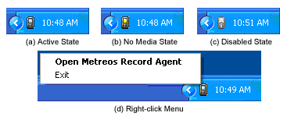
Figure 1: Record Agent System Tray Presence

Call Notifications
When any new call is initiated, whether incoming or outgoing, Record Agent pops a notification window containing call information and recording controls, as show in Figure 2.

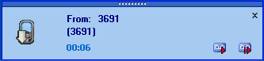
Figure 2: Call Notification Popup

Recording a Call
As soon as an incoming or outgoing call begins, Recording Agent begins silent background recording of the call. The recording is not saved to disk until you take action to either
- Start Recording; or
- Start Recording Now

When you ask to Start Recording, the recording is saved from the start of the call (or from the last stop point, if one exists). When you ask to Start Recording Now, the recording is saved beginning at the current point in the conversation. You can initiate recording in either manner from any of three places in the user interface:
- The call notification popup.
- The system tray image right click menu.
- The Record Agent main window.

Recording from the Call Notification Popup
Recording can be initiated from the notification popup window as shown in Figure 2 on page 14. To cause the call to be recorded to disk from the beginning of the call, click on the left image of the pair of icons shown in the lower right of the popup. To cause the call to be recorded beginning now, discarding any prior conversation for the call, press instead the right image of the pair.

Recording from the System Tray Menu
Recording can be initiated from menu available via right click of the Record Agent icon in the system tray, as shown in Figure 3. Right click on the Record Agent icon. When a call is active, the call dialed number appears on the menu. Mouse over the desired call on the menu, and the recording submenu appears. To begin recording, select Start Recording, or Start Recording Now, as described above. To stop an ongoing recording, select Stop Recording from the same menu.

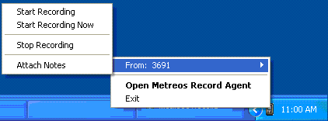
Figure 3: Recording Options from System Tray

Stopping and Restarting Recording of a Single Call
As described earlier, silent, unattended background recording of calls is always occurring when Record Agent is active. Stopping of a recording does not stop background recording. When you Stop Recording, you cause the current recording segment file to be closed and saved. If you subsequently select Start Recording, you ask that a new recording segment file for this call begin from the point at which you previously stopped recording. If you instead select Start Recording Now, the new file will start at the current spot in the conversation, and that portion of the conversation between the time you last stopped recording, and now, is discarded. Thus the recording of a single call may consist of multiple files, each associated with that call.

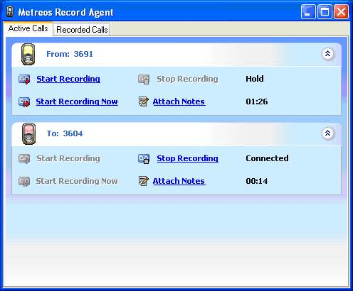
Figure 4: Record Agent Main Screen

Recording from the Main Application Screen
Recording can be initiated from the Record Agent application screen. To display the main screen, either double-click on the Record Agent icon in the system tray, or right-click on this icon and select Open Metreos Record Agent from the popup menu. The main screen and its Active Calls tab will appear, as shown in Figure 4, above. All calls active on your phone are displayed in this window. The familiar Start Recording, Start Recording Now, and Stop Recording options, as described earlier, are available here for each such call.

Annotating a Call
Each recorded call may be annotated with both a descriptive conversation topic, and with multiple time-stamped notes. To do so, press Attach Notes from either the main application screen, as shown above, or from the system tray menu as shown in Figure 3. Pressing Attach Notes causes the notes window to appear, as illustrated in Figure 5, following.
To enter or change the searchable conversation topic, do so in the Conversation Topic pane of this window. To supply a time-stamped note to be associated with this point in the conversation, enter the text of the note in the bottom pane of this window.
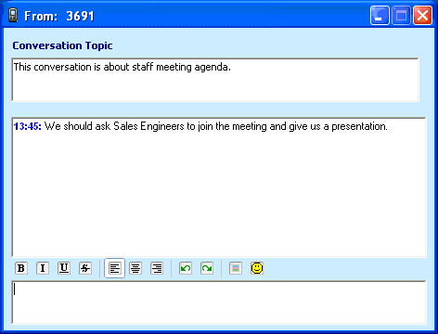
Figure 5: Notes Window

Managing and Playing Call Recordings
You can review and manage recording files, play back calls, and view call annotations, from the Call Recordings window, as shown in Figure 6 on page 14. To display this window, select the Recorded Calls tab near the top of the main application window.

Reviewing and Playing Back a Call
To play back a call and/or review a call’s annotations, click on the speaker icon located to the right of the call’s entry in the Call Recordings window, as shown in Figure 6. The Review Recorded Conversation window is displayed, as shown in Figure 7 on page 19. From here you can see the notes you have entered for this conversation, and can play back the call if you so choose.

Locating Conversations by Annotation Content
You can locate conversations by a keyword or phrase contained in the annotation topic or timestamped notes for a conversation. Pressing Search at the top of the Recorded Calls window causes a search box to appear. Enter the word or words you wish to search for, and press Find Now.

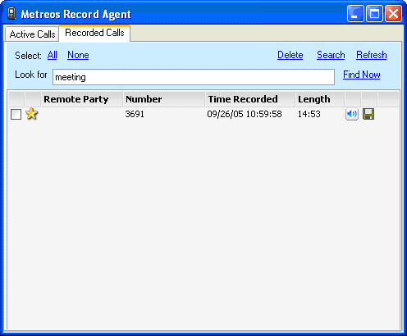
Figure 6: Recorded Calls Window

Bookmarking a Call
You can bookmark calls such that important calls can be grouped together. To do so, click in column 2 of the call entry in the Recorded Calls window (Figure 6). A bookmark icon will appear in this column. You can remove the bookmark by clicking again in the same manner. Clicking on the column 2 heading will cause this bookmark column to be ordered such that bookmarked calls are grouped together.

Saving a Call
Also from the Recorded Calls window (Figure 6), you can save the call and its associated annotations and metadata to a directory you specify. To do so, click the diskette icon located to the right of the desired call entry in this window. You will be prompted for a location to which to save the recording. Note that the call’s voice file or files will be saved in .au format, an audio format which is playable in any modern media player, including Windows Media Player, QuickTime, RealPlayer, and more.

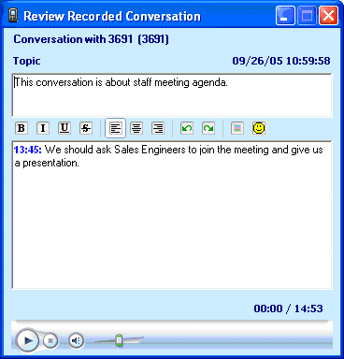
Figure 7: Review Recorded Conversation Window

If the tray image shows a yellow screen, as in Figure 1.b, no voice traffic is detectable, probably due to the network adapter being improperly configured, and you should therefore reselect a network adapter (Start Menu/Metreos Record Agent/Network Adapter Selector). If the tray image is in a disabled state, as in Figure 1.c, Record Agent’s packet capture service is not active, and call recording cannot occur.
Record Agent popups are of the disappearing type – the window will fade and disappear unless there is mouse activity over the popup window.

